***Assignment 1: Likelihood optimization***

The data set ***wind.xls*** represents **wind speed** records for twelve Meridian sites distributed around the New Zealand. It has long been known that the wind speed matches well with the Weibull distribution. Your task is to make **some inference** about the parameter values for the city **Otago**

1. Load necessary information concerning **Otago city to R.** Plot the histogram of the **wind speed** and **comment** whether it looks like Weibull (you may also compare it with the shape of the related **Rayleigh distribution**)

**Solution:**

data<-read.csv("otago-wind.csv",header=TRUE,",");

hist(data$Otago) **\*0.5p**

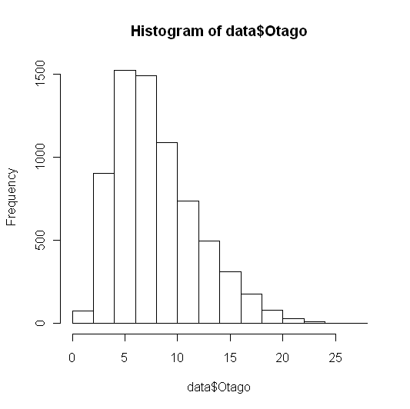

[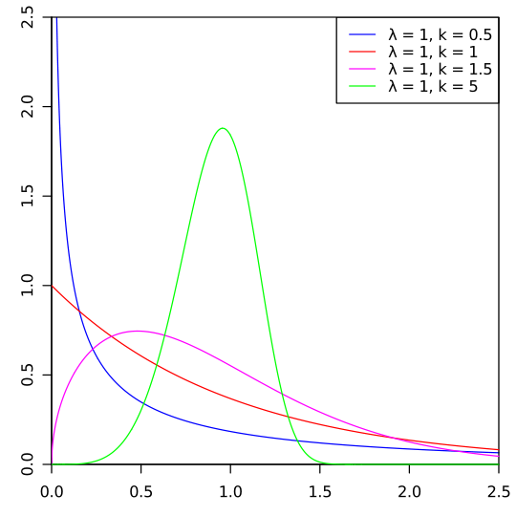](http://upload.wikimedia.org/wikipedia/commons/5/58/Weibull_PDF.svg) [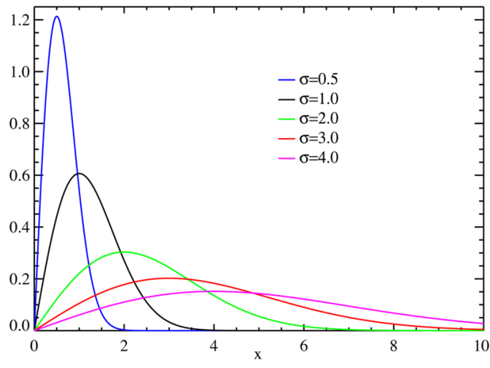](http://upload.wikimedia.org/wikipedia/commons/6/6a/Rayleigh_distributionPDF.png)

The wind speed will have a Rayleigh distribution if the components of the two-dimensional wind velocity vector are uncorrelated and normally distributed with equal variance. So it seems like Rayleigh. **\*0.5p**

1. Write your **own function** as a **parameter of the data** that finds the **maximum log-likelihood estimates of the parameters *shape* and *scale*** of the Weibull distribution by using an optimization method such as BFGS or CG. Compute the parameter estimates (if you get warnings, ignore them). **What kind of problems may one encounter when these methods are used for the search of the maximum log-likelihood estimates?** What other **methods can you see as alternatives that do not have these problems?**

**Solution:**

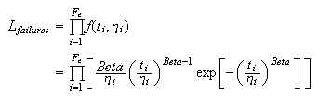

############# log likelihodd code#############

data<-read.csv("otago-wind.csv",header=TRUE,",");

hist(data$Otago)

initParams <- c(1, 1.5);

loglikelihood<-function(k){

shape<-k[1];

scale<-k[2];

temp<- sum(dweibull(data$Otago, shape=shape, scale = scale, log = TRUE));

return(-temp);

}

###### Maximization using optim with CG and BFGS####

> initParams <- c(1, 1.5);

> loglikelihood(initParams)

[1] 39826.94

>

> optim (initParams, loglikelihood, method="CG")

$par

[1] 2.163650 9.063085

$value

[1] 18899.50

$counts

function gradient

540 101

$convergence

[1] 1

$message

NULL

There were 25 warnings (use warnings() to see them)

>

> optim (initParams, loglikelihood, method="BFGS")

$par

[1] 2.163649 9.063077

$value

[**1] 18899.50**

$counts

**function gradient**

**38 9**

$convergence

[1] 0

$message

NULL

**\*2p**

***What kind of problems may one encounter when these methods are used for the search of the maximum log-likelihood estimates?***

In case of conjugate gradient, because this is the large data set having weibel distribution might need hessian estimates to find out the correct shape & scale.

**\*0.5p this is not the main reason**

***What other methods can you see as alternatives that do not have these problems?***

Maybe Newton’s method converge more accurate with hessian matrix rather than approximation of it as BFGS do. **\*0p Newton will have some other problems…**

1. Modify your function in such way that it **returns only *shape* parameter**. Consider this function as an estimator of *shape* and generate 100 bootstrap **estimates of this parameter.** Produce an appropriate **plot and make comments**. Compute 95% confidence bounds (**using percentile method only!**) for **the parameter *shape* and answer whether the data can in principle come from Rayleigh distribution**.

**Solution:**

loglikelihood<-function(k){

shape<-k[1];

scale<-k[2];

index<-k[3];

temp<- sum(dweibull(data$Otago[index], shape=shape, scale = scale, log = TRUE));

return(-temp);

}

funcshapescale<-function(data,index){

initParams <- c(1, 1.5,index);

res<-optim (initParams , loglikelihood, method="BFGS");

res$par[1]

}

res<-boot(data$Otago, funcshapescale, R=10, sim="ordinary", stype="i");

boot.ci(boot.out = res, conf=0.95, type=c("perc"));

**\*0.5p Code needs to be further optimized…**

***Assignment 2: Computing an integral***

Consider the distribution with density $f\left(x\right)=\frac{π}{2}\sin\left(πx\right), 0<x<1$

1. Write **your own function** that can generate **sample of size *n*** from the distribution above using the **acceptance-rejection** method with uniform distribution as the majorizing density. The function should also compute what p**ercent *R***of the totally **generated random numbers was rejected in this method**. What was the value of the scaling constant *c* you used in deriving the majorizing function and why you have chosen this value?
2. Generate a sample of size 1000 by using your function and plot the histogram. Does the sample look like it should?
3. Print out the computed rejection rate ***R***. Find out without using computer what would be the rejection rate ***R*** if the sample size would be very large (i.e., the expected value of ***R***).
4. Use the obtained sample to compute the value of the integral **to derive the value of the integral $\int_{0}^{1}{\frac{\sin\left(πx\right)}{5+x^{2}}dx}$** by applying the importance sampling. Why using the introduced above $f\left(x\right)$ as importance function is better than using the density of the uniform distribution?
5. Compute the same integral by using the function *integrate* in R and comment on the result.

## Submission procedure

Submit your solutions via It’s learning at latest by 24 May, 13:00